**Scenario:**

*“You’ve been hired as a data scientist for MMC Direct, a medical motorcycle courier company. MMC prides itself on providing safe and efficient deliveries of important medical items (including lab specimens, medications, and transplant organs) between labs and hospitals throughout the North Carolina Piedmont region. ”*

**Question:**

How efficient is the recent routing | Where are the inefficiencies?

**Ideas:**

How much does the actual delivery time differ from the estimated delivery time?

How long did the employee take a break before delivering the next shipment?

How much distance each delivery person traveled per day, and how many orders they deliver?

**Variable created:**

*‘distance’* : calculate distance between clients based on latitude and longitude.

*‘delivery_time’ :* actual delivery time in minutes.

*‘total_dist’*: total distance traveled by each rider.

*‘rest_time_mins”*: rest time between orders in minutes.

*A new sheet called “analysis” is also created for analysis*

**Data Exploration:**

* Each day contains some NA values corresponding to the number of unfilled orders for each day

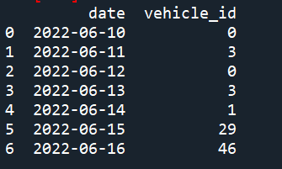

* Calculate the distance between each client from the latitude and longitude values
* Number of orders received per day

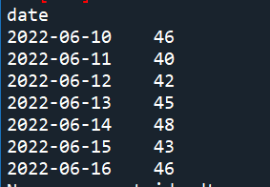

* Average length of break between orders per rider (different dates can be selected)

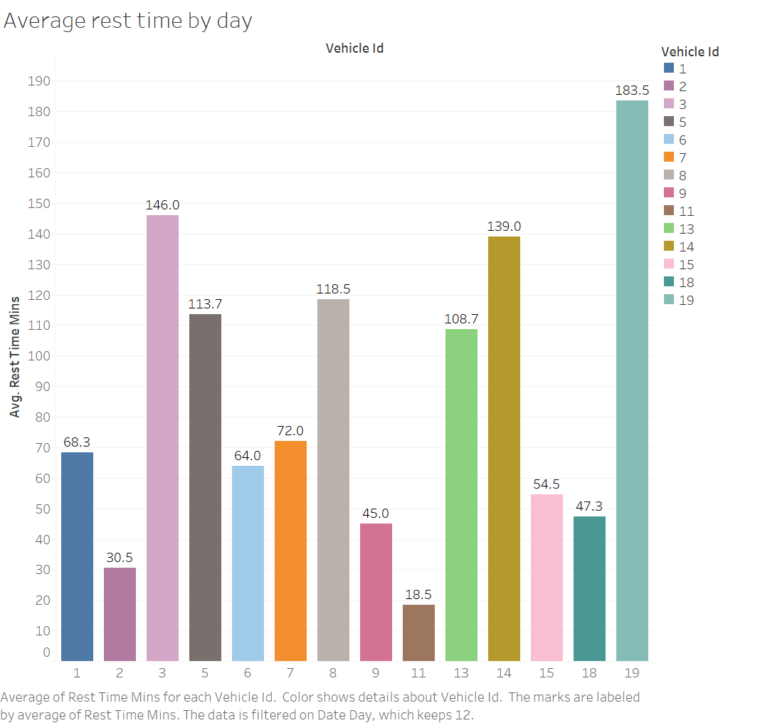

* Distance traveled per driver per day

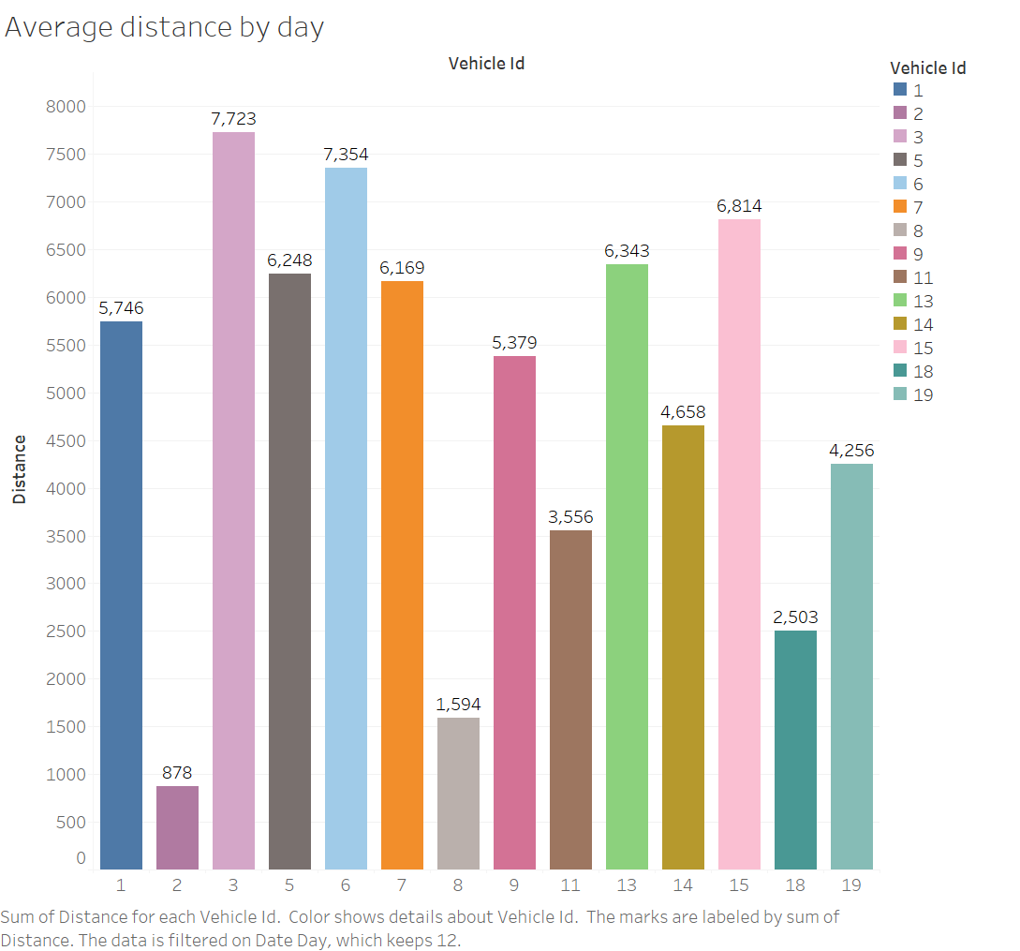

* Calculate the difference between the actual delivery time and the estimated delivery time [(Actual delivery time / estimated delivery time) - 1]

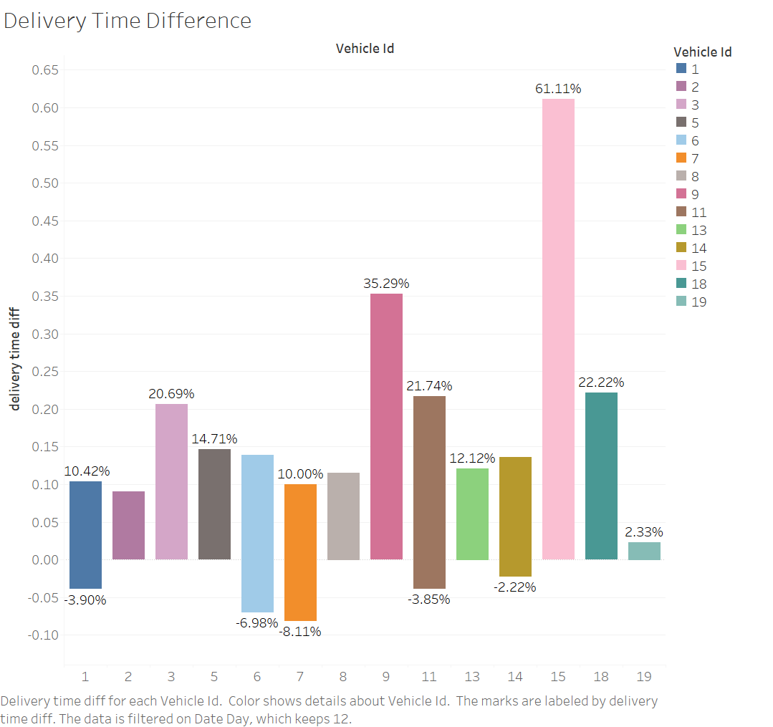

* Number of orders completed per rider per day

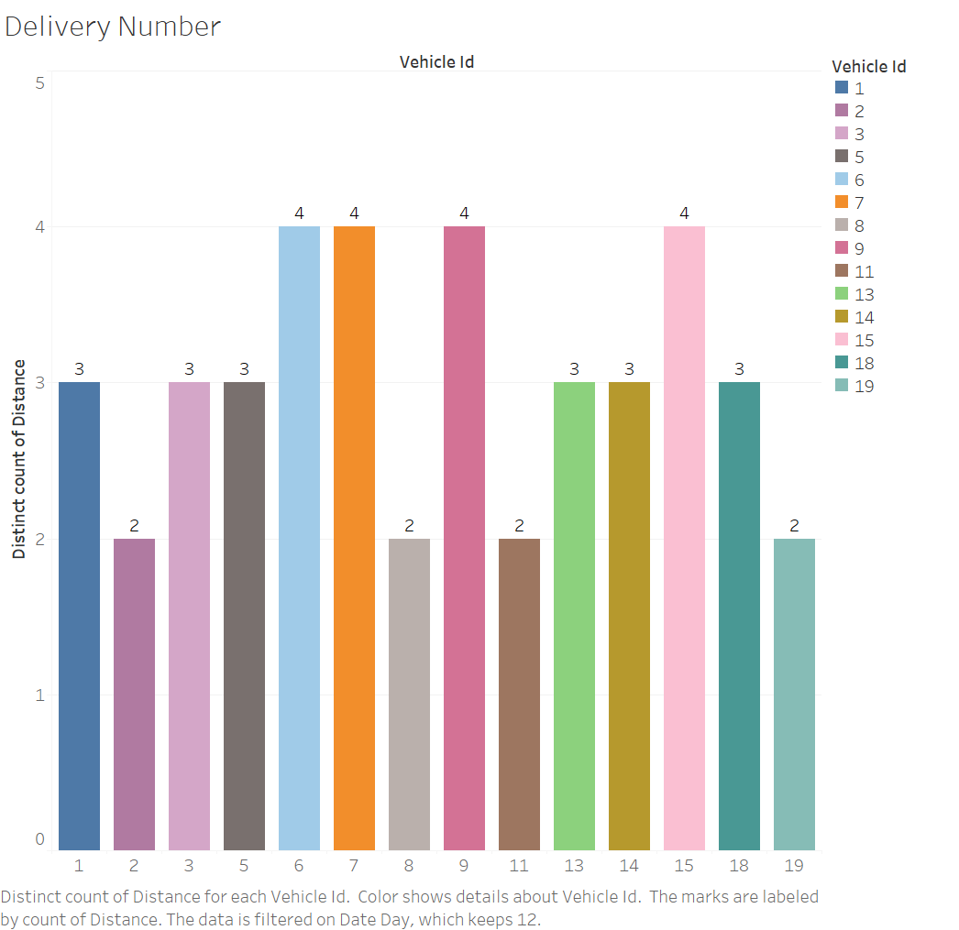

**Analysis:**

* The number of orders received by MMC per day ranges from 40-50, and the number of orders completed by each driver per day ranges from 1-7.
* According to the data available so far, the number of unfilled orders per day ranges from 0-3.
* The rest time between orders received by each rider varies, with some as long as more than 3 hours. Therefore, tighter scheduling is needed to make riders more productive during working hours.
* Riders also travel very different distances each day, some up to nearly 8,000km, and at the same time, the number of orders they complete each day varies, with some riders completing up to seven orders a day. Therefore, a more reasonable distance planning and individual scheduling plan for each rider is needed.
* There is also a difference between the actual delivery time and the estimated delivery time. Most of the transport times are longer than estimated, except for objective factors (traffic, motorcycle breakdowns, etc.), which require more rational distance planning and rider-specific time limits.